Three-Point Collinearity

Definition
# Source: AI Source: Provided by: [Data Path: Persons Table -> ID Column: 1, Name_En Column: Motasem Essam] -> From: [ChatGPT] on [7/25/2026]
Three-Point Collinearity is a type of collinearity in which three distinct points lie on the same straight line.
For three points $A$, $B$, and $C$, they are collinear if there exists a single straight line $l$such that:
$$A,B,C∈l$$
If no single straight line contains all three points, they are non-collinear.
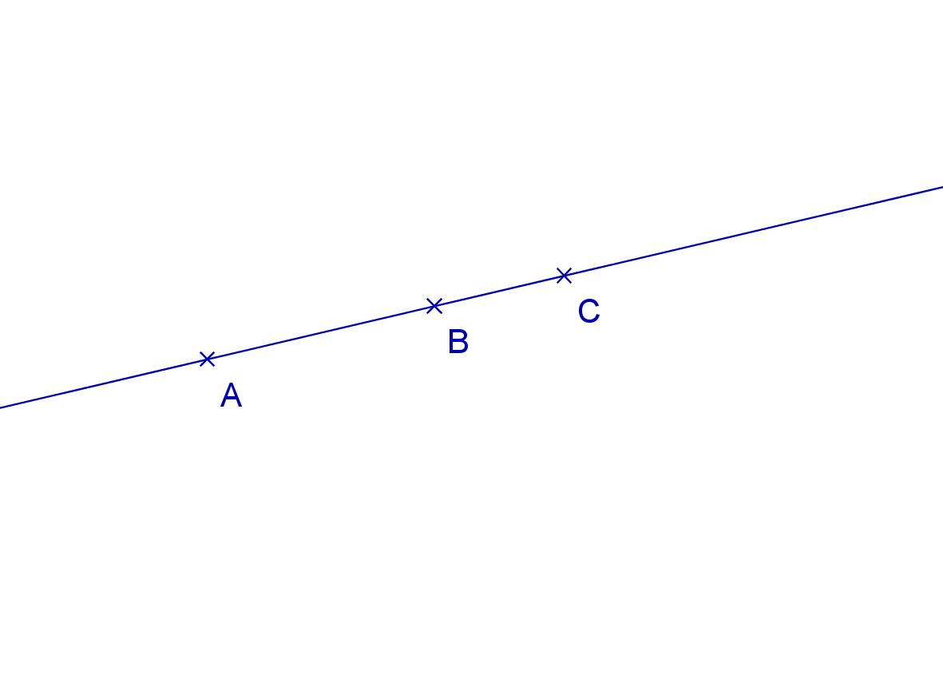
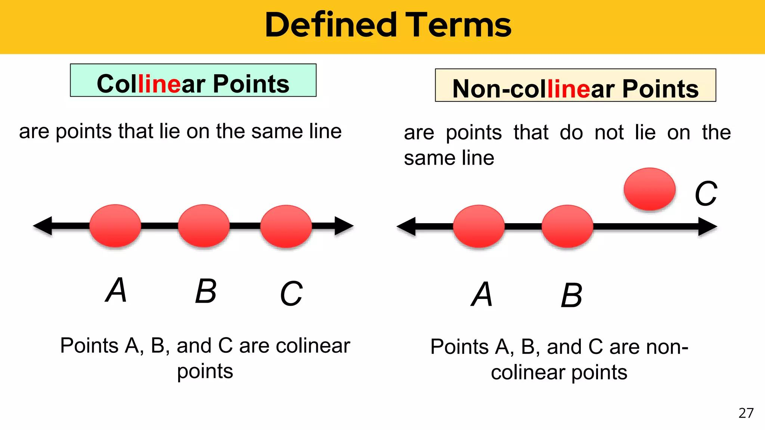
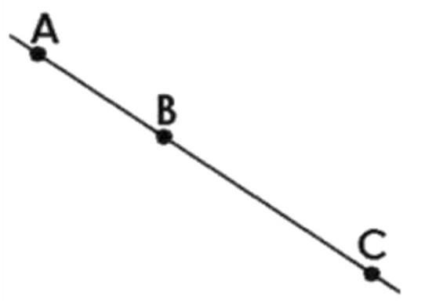
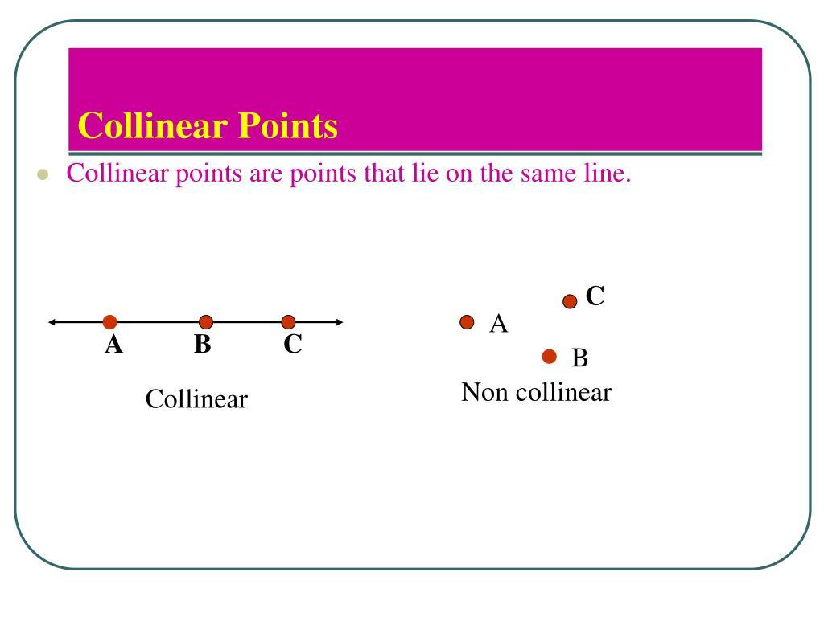

Purpose
# Source: AI Source: Provided by: [Data Path: Persons Table -> ID Column: 1, Name_En Column: Motasem Essam] -> From: [ChatGPT] on [7/25/2026]
Three-point collinearity is used to:
- Determine whether three points lie on the same straight line.
- Establish whether three points can form a triangle.
- Verify geometric constructions.
- Analyze line segments and their relationships.
- Solve coordinate-geometry problems.
- Establish whether a point lies on the line determined by two other points.

Fundamental Concept
# Source: AI Source: Provided by: [Data Path: Persons Table -> ID Column: 1, Name_En Column: Motasem Essam] -> From: [ChatGPT] on [7/25/2026]
The key distinction from Two-Point Collinearity is that two distinct points are automatically collinear, while three points are not necessarily collinear.
For:
$$A,B,C$$
there are two possibilities:
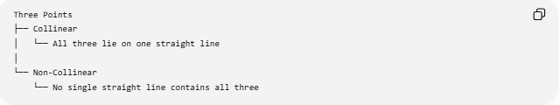
Three Points
├── Collinear
│ └── All three lie on one straight line
│
└── Non-Collinear
└── No single straight line contains all three
Collinear
A ●────────● B ────────● C
$$A,B,C∈l$$
Non-Collinear
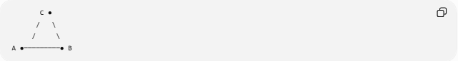
C ●
/ \
/ \
A ●─────────● B
No single straight line contains $A$, $B$, and $C$.

Mathematical Conditions
# Source: AI Source: Provided by: [Data Path: Persons Table -> ID Column: 1, Name_En Column: Motasem Essam] -> From: [ChatGPT] on [7/25/2026]
For three distinct points:
$$A\left(x_{1} , y_{1}\right), B\left(x_{2} , y_{2}\right), C\left(x_{3} , y_{3}\right)$$
they are collinear if the three points lie on the same line.

1. Equal-Slope Test
# Source: AI Source: Provided by: [Data Path: Persons Table -> ID Column: 1, Name_En Column: Motasem Essam] -> From: [ChatGPT] on [7/25/2026]
When the relevant denominators are nonzero:
$$\frac{y_{2}-y_{1}}{x_{2}-x_{1}}=\frac{y_{3}-y_{1}}{x_{3}-x_{1}}$$
Therefore:
$$\boxed{m_{AB}=m_{AC}}$$
If the slopes are equal, the three points are collinear.
Example
$$A\left(1 , 2\right), B\left(3 , 6\right), C\left(5 , 10\right)$$
Calculate:
$$m_{AB}=\frac{6-2}{3-1}=2$$
and:
$$m_{AC}=\frac{10-2}{5-1}=2$$
Since:
$$m_{AB}=m_{AC}$$
the points are collinear.

2. Determinant / Zero-Area Test
# Source: AI Source: Provided by: [Data Path: Persons Table -> ID Column: 1, Name_En Column: Motasem Essam] -> From: [ChatGPT] on [7/25/2026]
Three points are collinear if the triangle formed by them has zero area.
$$A_{△ABC}=0$$
Using coordinates:
$$\left(x_{2}-x_{1}\right)\left(y_{3}-y_{1}\right)-\left(y_{2}-y_{1}\right)\left(x_{3}-x_{1}\right)=0$$
Thus:
$$\boxed{\left(x_{2}-x_{1}\right)\left(y_{3}-y_{1}\right)-\left(y_{2}-y_{1}\right)\left(x_{3}-x_{1}\right)=0}$$
This test also works for vertical lines and avoids division by zero.

Example
Consider:
$$A\left(2 , 3\right), B\left(5 , 7\right), C\left(8 , 11\right)$$
Calculate:
$$\left(5-2\right)\left(11-3\right)-\left(7-3\right)\left(8-2\right) \\ =3\left(8\right)-4\left(6\right) \\ =24-24 \\ =0$$
Therefore:
$$\boxed{A,B,C\text{ are collinear}}$$

3. Triangle-Area Test
# Source: AI Source: Provided by: [Data Path: Persons Table -> ID Column: 1, Name_En Column: Motasem Essam] -> From: [ChatGPT] on [7/25/2026]
Three points are collinear exactly when the triangle they would form is degenerate.
$$\boxed{A_{△ABC}=0}$$
If:
$$A_{△ABC}>0$$
then the points are non-collinear.
Conceptually:
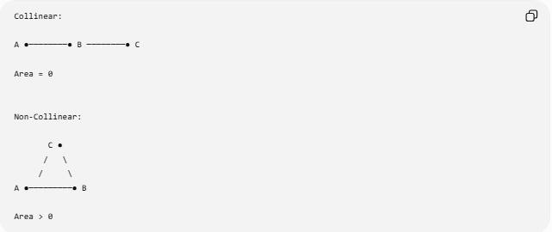
Collinear:

A ●────────● B ────────● C

Area = 0

Non-Collinear:

C ●
/ \
/ \
A ●─────────● B

Area > 0

Relationship to Triangles
# Source: AI Source: Provided by: [Data Path: Persons Table -> ID Column: 1, Name_En Column: Motasem Essam] -> From: [ChatGPT] on [7/25/2026]
Three distinct points have an important relationship with triangle formation.
Collinear points
Three collinear points cannot form a non-degenerate triangle.
$$A_{△ABC}=0$$
Non-collinear points
Three non-collinear points determine a unique triangle:
$$A_{△ABC}>0$$
Therefore:
$$\boxed{\text{Three points form a triangle }⟺\text{ they are non-collinear}}$$

Point Between Two Other Points
# Source: AI Source: Provided by: [Data Path: Persons Table -> ID Column: 1, Name_En Column: Motasem Essam] -> From: [ChatGPT] on [7/25/2026]
If three points are collinear, one point may lie between the other two.
For example:
A ●────────● B ────────● C
Here $B$lies between $A$and $C$.
This gives the segment relationship:
$$AB+BC=AC$$
This is called the Segment Addition Postulate.
However, collinearity itself does not require one point to be between the other two. For example:
B ●───────● C───────● A
The points remain collinear regardless of their labeling or order.

Collinearity and a Common Line
# Source: AI Source: Provided by: [Data Path: Persons Table -> ID Column: 1, Name_En Column: Motasem Essam] -> From: [ChatGPT] on [7/25/2026]
If $A,B,C$are collinear and $A≠B$, then the line determined by $A$and $B$also contains $C$:
$$C∈\overset{↔}{AB}$$
Equivalently:
$$\boxed{A,B,C\text{ are collinear}}$$
if and only if:
$$\boxed{C∈\overset{↔}{AB}}$$
provided $A≠B$.

Three-Point Collinearity in Coordinate Geometry
# Source: AI Source: Provided by: [Data Path: Persons Table -> ID Column: 1, Name_En Column: Motasem Essam] -> From: [ChatGPT] on [7/25/2026]
For points on a line:
$$y=mx+b$$
each point satisfies the same equation.
For example:
$$A\left(1 , 3\right), B\left(2 , 5\right), C\left(4 , 9\right)$$
All satisfy:
$$y=2x+1$$
because:
$$3=2\left(1\right)+1 \\ 5=2\left(2\right)+1 \\ 9=2\left(4\right)+1$$
Therefore, all three points lie on the same line.

Collinear vs. Non-Collinear
# Source: AI Source: Provided by: [Data Path: Persons Table -> ID Column: 1, Name_En Column: Motasem Essam] -> From: [ChatGPT] on [7/25/2026]
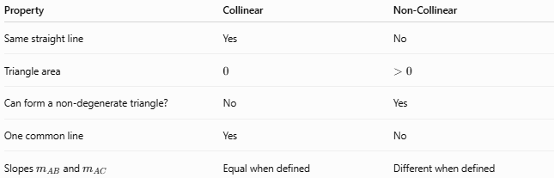
Property | Collinear | Non-Collinear
Same straight line | Yes | No
Triangle area | $$0$$ | $$>0$$
Can form a non-degenerate triangle? | No | Yes
One common line | Yes | No
Slopes $m_{AB}$and $m_{AC}$ | Equal when defined | Different when defined

Three-Point Collinearity vs. Two-Point Collinearity
# Source: AI Source: Provided by: [Data Path: Persons Table -> ID Column: 1, Name_En Column: Motasem Essam] -> From: [ChatGPT] on [7/25/2026]
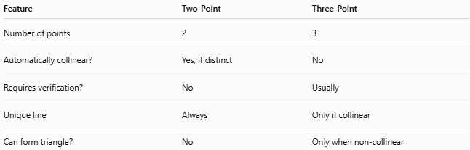
Feature | Two-Point | Three-Point
Number of points | 2 | 3
Automatically collinear? | Yes, if distinct | No
Requires verification? | No | Usually
Unique line | Always | Only if collinear
Can form triangle? | No | Only when non-collinear
Thus, Three-Point Collinearity is the first meaningful test of collinearity because three points can either lie on one line or fail to do so.

Key Points
# Source: AI Source: Provided by: [Data Path: Persons Table -> ID Column: 1, Name_En Column: Motasem Essam] -> From: [ChatGPT] on [7/25/2026]
- Three-point collinearity involves three points lying on one straight line.
- Three distinct points are not automatically collinear.
- Equal slopes can establish collinearity when the slopes are defined.
- The determinant/zero-area test works generally.
- Three collinear points form a degenerate triangle with area $0$.
- Three non-collinear points form a non-degenerate triangle.
- If $A,B,C$are collinear, then $C$lies on $\overset{↔}{AB}$.
- Collinearity does not require one point to lie between the other two.

Conclusion
# Source: AI Source: Provided by: [Data Path: Persons Table -> ID Column: 1, Name_En Column: Motasem Essam] -> From: [ChatGPT] on [7/25/2026]
Three-Point Collinearity describes the condition in which three distinct points lie on the same straight line. Unlike two-point collinearity, it is a relationship that must be established because three points may either be collinear or non-collinear. It is fundamental to coordinate geometry, line determination, segment relationships, and the distinction between degenerate and non-degenerate triangles.
Would you like to continue with multi-point collinearity or compare the main collinearity tests?

